

**Natural Language Processing Project**

**Title : Sentimental Analysis Of Twitter**

**Submitted To: GROUP MEMBERS :**

**Dr. Yogesh Kumar Meena Devendra Dodwadiya – 2012ucp1553**

**Ranjeet Kumar - 2012ucp1571**

**Abstract**

Fog phenomena result in airlight generation and degrade the visibility of the color image captured from the camera. To improve visibility, airlight estimation is necessary for image fog removal. As airlight is very bright, the traditional methods directly select bright pixels for airlight estimation. However, some bright pixels generated by light sources, such as train headlights, may interfere with the accuracy of the above-mentioned methods. In this paper, we propose a new airlight estimation method. Based on Gaussian distribution, the proposed method selects the airlight candidates in the brightest region of the input image. Moreover, the color similarity estimation is also applied to hierarchically reﬁne the candidates. We then compute the average color from the reﬁned candidate pixels for airlight estimation. Experimental results demonstrate that the proposed method is more accurate than other airlight estimation methods and has low time complexity.

**Related Areas:**

Haze removal (or dehazing) is highly desired in both

* **consumer/computational photography**
* **computer vision applications**

**Objective of the Work**

In general, object color corresponds to the light reﬂected from an object. The perceived object color is degraded if the reﬂected light partially transmits from fog to observer. Let L0 be the reﬂected light of an object and L 1 be ambient light. The presented light of object L can be formulated by



In general, airlight estimation can be performed by manual and automatic methods. The manual method directly deﬁnes image regions affected by airlight , but it is inapplicable for realistic application due to frequent interruption. In contrast, the automatic methods are more convenient. Thus, we estimate airlight in single images automatically . However, the traditional methods select only bright pixels as candidates of airlight regions. This means that if bright pixels generated by light sources exist in the input images, those methods may select inappropriate candidates that result in wrong airlight estimation. In this project, we focus solely on the challenge of accurate airlight estimation.

**List of Techniques Used in the Research Article**

Basically, the proposed HAE method has two characteristics:

1. It computes the color probability to select precise candidates for airlight estimation.

2. It does not construct the dark channel before airlight estimation.

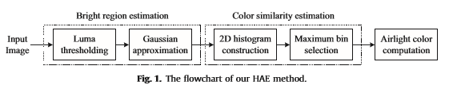

**1. Bright region estimation**

In image processing, histograms are widely used for thresholding (Otsu et al.,1979). As such, we construct the luma histogram to determine bright regions of the input image. Let Y be the luma channel of YCbCr color space for the input image Ic. The histogram of Y is generated by the probability density function (pdf) expressed below:

haeFLow.png

where Ymin is the minimum value of Y, Ymax is the maximum value of Y, and y is an arbitrary value of Y.

**1.1. Luma thresholding**

For each pixel of the input image, it is selected as a rough candidate if its luma value is greater than μ.

haeFLow.png

**1.2. Gaussian approximation**

If the luma value of the rough candidate does not lie within it is removed as a non-candidate pixel.

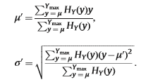

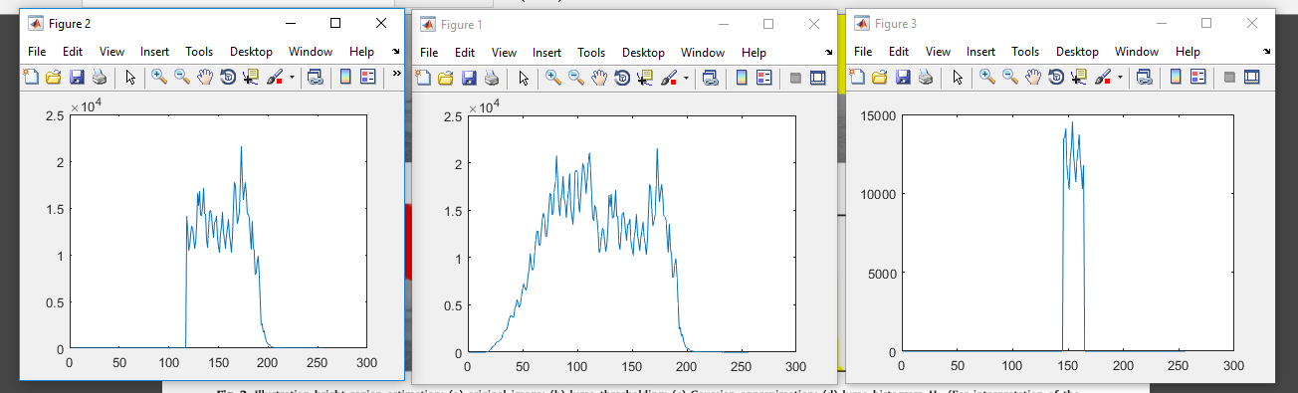

Figure1:Probability distribution of all Y values

Figure2:Values greater than luma thresholding

Figure3:Gaussian Approximation Range

**2. Color similarity estimation**

Let Cb and Cr be the chroma channels of YCbCr color space for the input image Ic. We then compute the absolute difference of chroma per pixel, which can be expressed as follows:



**2.1 2D histogram construction**

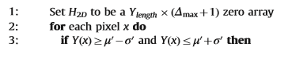

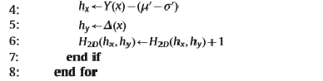

**2.2. Maximum bin selection**

In the selected candidates, the most representative pixels have the same color information and the highest probability densities. Hence, we select the maximum bin of H2D denoted by



**3. Airlight color computation**

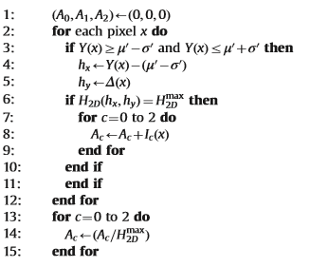

After generating Ac, it can be supplied to improve various image fog removal methods based on the physical optic model

**List of Datasets Used**

INPUT IMAGES

**Fig.1**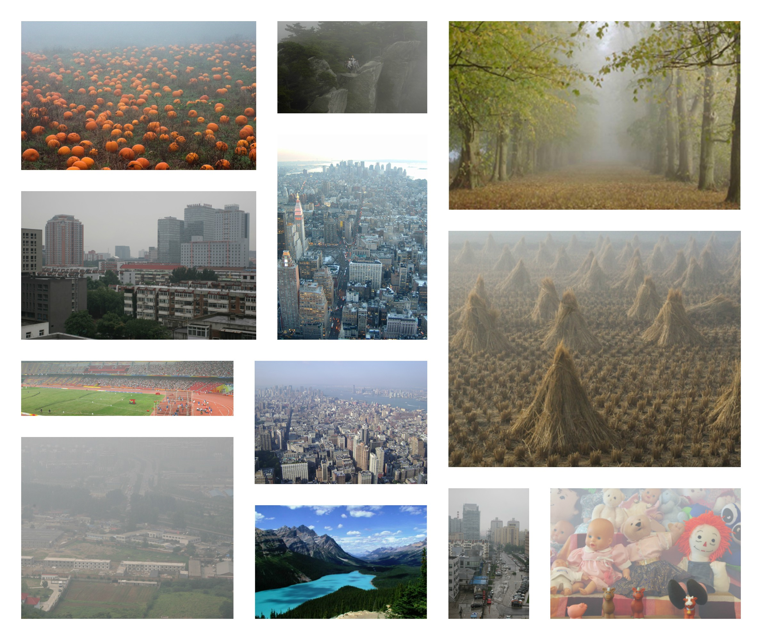

**Tools Used (Versions)**

* **MATLAB(2016b)**
* **Image Processing ToolBox(MATLAB)**
* **Technical Description of the Work (with Flowchart)**



**Performance Measures Used**

* **MATLAB timer function to calculate the execution code for single image**

**Experimental Results**

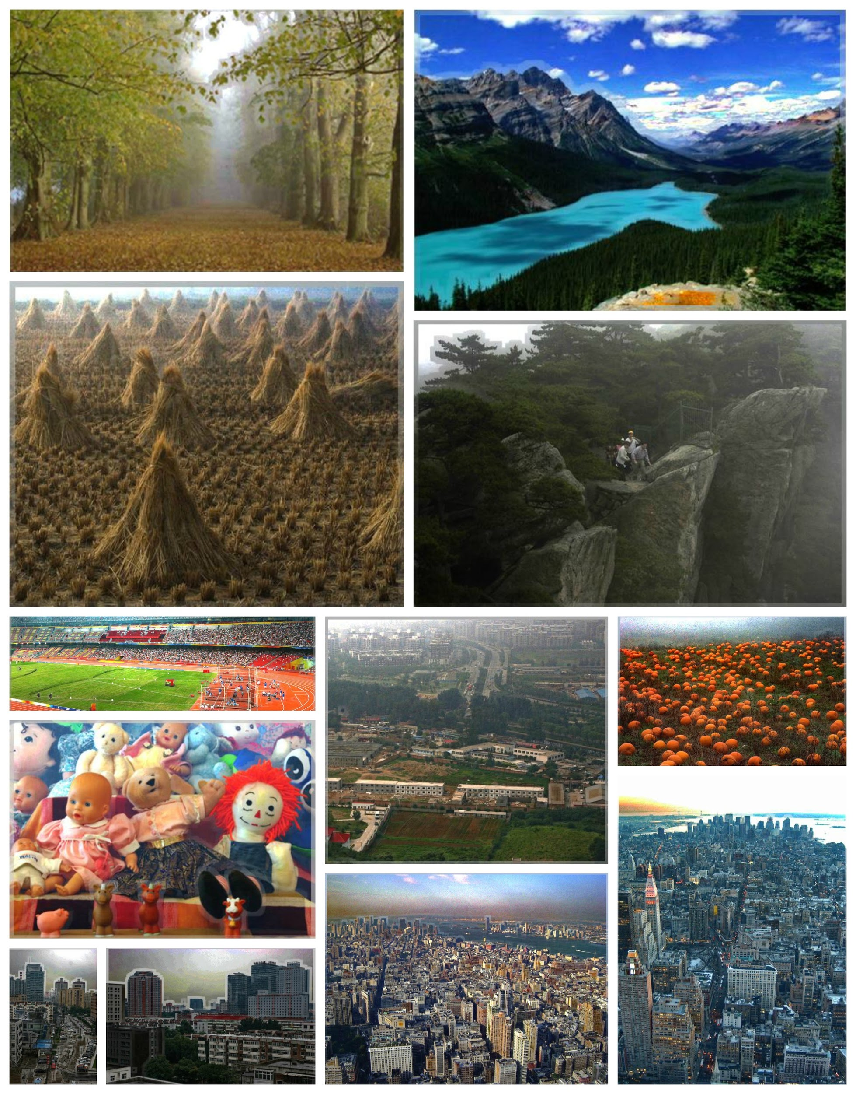

**Fig.2**

**Conclusion & Future Scope**

This project has proposed a linear time airlight estimation algorithm based on color analysis. Compared to the previous methods that only focus on luminance estimation, the proposed method estimates the color probability in YCbCr space to select candidates of the representative fog pixels for airlight computation. According to qualitative evaluation by visual inspection, quantitative assessment using FSIM metric, Big-O notation, and execution time estimation, we have veriﬁed that our proposed method is more effective than the compared methods and has very low computation cost. In our future work, we will research the effective transmission model module in order to obtain an optimal defogging solution.

More advanced models can be used to describe complicated phenomena, such as the sun’s influence on the sky region, and the bluish hue near the horizon. We intend to investigate haze removal based on these models in the future. In future we extend our image haze removal method to video. And in future we will improve the proposed technique to achieve better utility and performance.

**References**

**[1] A hierarchical airlight estimation method for image fog removal**

Fan-Chieh Cheng, Chung-Chih Cheng, Po-Hsiung Lin, Shih-Chia Huangn

URL : www.sciencedirect.com/science/article/pii/S0952197615000639